October 23rd, 2018

To the Editors at Nature Human Behavior,

Please find attached our paper “Any way the brain blows? The nature of decision noise in random exploration.” In this paper we investigate the nature of behavioral variability and its role in exploration.

Behavioral variability has long been thought to be useful for exploration (e.g. Sutton & Barto 1998). By behaving “randomly,” we might try something new, which can lead to new insights into a problem or new ways to obtain reward. In line with this intuition, recently we have shown that people adapt their behavioral variability according to how valuable it is to explore – becoming more random in their responses as the value of exploration is increased (Wilson et al. 2014). This finding suggests that people adapt their behavioral variability in the service of exploration, but leaves open the question of how exactly they do it.

In particular, there are two quite different ways in which people could alter their behavioral variability. In the “external noise” strategy, they could simply pay more attention to irrelevant stimuli in the world, allowing the distraction of random external cues to increase the variability in their response. In the “internal noise” strategy, variable responding could be driven more directly, by random neural firing in the brain. Previous work makes a strong case for both types of noise being relevant to behavior. For instance, external, stimulus-driven noise is thought to be a much greater source of choice variability in perceptual decisions than internal noise (Brunton et al 2013). Conversely, internal neural noise is thought to drive exploratory singing behavior in song birds and the generation of this internal noise has been linked to specific neural structures (). Thus it is unclear which type of noise humans would use for random exploration.

Using a modified version of our explore-exploit task, in which we controlled the external stimuli and let people make decisions in repeated identical scenarios, we were able to statistically distinguish internal and external decision noise by assessing the degree to which human participants make consistent decisions. If noise is purely externally driven, then people should make identical choices in repeated scenarios. However, if noise is purely internally driven, then people should less consistent in their choice. By looking at the extent to which people make inconsistent choices, we were able to show that, while both internal and external noise were present in the explore-exploit choice, only internal noise changed as exploration became more valuable.

These findings suggest that random exploration is almost entirely driven by internal noise and that human exploration in a cognitive decision making task looks very much like the motor exploration of song birds practicing their song. This suggests the intriguing idea that the noise generating neural circuits found in the song bird motor learning system, may also be present in humans and, more generally, may be a common method of exploration across species.

Given the broad implications of our findings and the growing interest in the causes of, and roles for, behavioral variability, we believe that our work will be of interest to a wide range of researchers in psychology, cognitive science and neuroscience. As such we believe this paper is a good fit for Nature Human Behavior.

Sincerely,

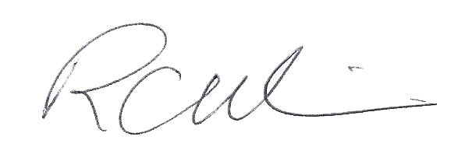

Robert Wilson, Ph.D.

**References**

B. W. Brunton, M. M. Botvinick, and C. D. Brody. Rats and humans can optimally accumulate evidence for decision-making. *Science*, 340(6128):95–98, Apr 2013.

M. H. Kao, A. J. Doupe, and M. S. Brainard. Contributions of an avian basal ganglia-forebrain circuit to real-time modulation of song. *Nature*, 433(7026):638–643, Feb 2005.

Sutton, R. S., Barto, A. G., & Bach, F. (1998). *Reinforcement learning: An introduction*. MIT press.

R. C. Wilson, A. Geana, J. M. White, E. A. Ludvig, and J. D. Cohen. Humans use directed and random exploration to solve the explore-exploit dilemma. *J Exp Psychol Gen*, 143(6):2074–2081, Dec 2014.